**Project report**

**Circuit diagram, state machine and LCL filter**

**Jeries Jubran 208659763**

**Khalid Dahly 318539541**

* **Circuit connection**we include the Guasch MTL-CBI0060F12IXHF and connect the circuit:

Addressing each input and output separately (as needed):

* **U,V,W**: the outputs of the Guasch will be connected through the LPF (LCL filter) to the grid.
* **R,S,T:**
* **VDC+R , VDC-:** these are connections of the power supply – positive and negative terminals.

The (simple) circuit is as follow:

HV BREAKER CIRCUIT + PRECHARGE RELAY

grid

SAMPLING

SAMPLING

CONTROLLER



***STATE MACHINE:***

close manual switch, soft start relays

Calibration

precharge

idle

Open soft start relays ,close circuit breaker and synchronize

open relays and discharge

open relays and discharge

Open switches and discharge capacitors

Ongrid

Offgrid

Run the inverter switches and Insert active power

* ***Calibration:***

In order for the circuit to work accordingly and have the right values of current and voltage, we have to calibrate our measuring equipment.

This means that if when we have a measurement of 100V from the probe, then this must be the real value.  
we perform calibration by forcing the voltage or current to be specific known values. We check if these are the values we get in the measurement and calibrate accordingly.

For example, for the current probe we force it to be 0[A] by measuring in open circuit.

* ***Idle:***

all switches open, no current is flowing in the circuit.

* + ***Close manual switch, soft relays on grid side:***

Close the manual switch before the grid, and the relays for the precharge of the capacitors through the resistors.

* **Precharge:**

the state in which the capacitors are charging. Once the LCL filter capacitors and the Guasch capacitor charged we move to the next state.  
The purpose of precharge is to protect the circuit’s components and to prevent high current from flowing initially which might damage the circuit. During this step, the circuit is not connected to the grid, the capacitors charge gradually either through the grid or the DC side, and the current doesn’t surpass the maximum limit.

this step is very important in high voltage circuits.

* + **Open soft start relays ,close circuit breaker and synchronize:**

We close the circuit breakers (HV relays) and we start synchronization algorithms to synchronize with the grid.

* **Offgrid:**

The circuit is synchronized with the grid, however it is still off grid and no power is being inserted into the grid.

* + **Run the inverter switches and Insert active power:**

we start running the Guasch switches (IGBTs) according to the synchronization algorithm, then we insert active power by creating a positive phase difference between the Guasch and the grid so that current can flow from the inverter to the grid.

* **Ongrid:**

After the inverter is synchronized with the grid, the capacitors are charged and the switches are operating. Active power is being inserted into the grid.

If for whatever reason the circuit stops synchronizing, or there is an error, or any of the values exceed their maximum limit or if we just want to go off grid for whatever reason, we disconnect from the grid by opening all switches and the circuit breaker and discharging the capacitors and going back to idle mode.

We can see below the maximum values for Guasch components that is 750[V]. in case the measured DC input voltage is 850[V] we disconnect from the grid and move to idle

* **LCL Filter and its transform function**

This is a LPF (low pass filter). It filters out the harmonics in the current in order for the wave to be as close as possible to an ideal sinusoidal. This is what transforms the inverters output which is a result of PWM (made of pulses of different widths) into a sine wave.

The transform function $H\left(s\right)=\frac{I_{out}}{V_{in}}$ is given by:

$$H\left(s\right)=\frac{1}{s\left(L_{1}+L_{2}\right)\left(1+s^{2}\frac{L_{1}L_{2}C}{L_{1}+L_{2}}\right)}$$

We substitute $L=L_{1}+L_{2} ; L_{p}=\frac{L_{1}L_{2}}{L_{1}+L_{2}}$

Therefore, the resonance frequency is $ω_{r}=\frac{1}{\sqrt{L_{p}C}}$

The Bode plot of the amplitude is given be:

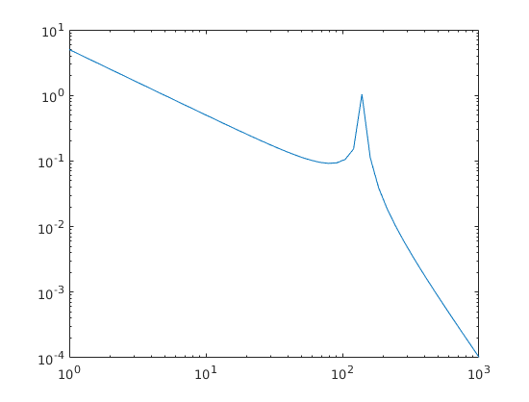

$$-\frac{20dB}{dec}$$

$$-\frac{60dB}{dec}$$

Resonance frequency

We must demand that the resonance frequency be much larger than the frequency of the circuit and much smaller than the frequency of the switches (PWM).

**Some questions and points that need clarifications:**

1. Regarding the AC and DC connections we didn’t know which connections to choose. We saw there are many types of connections, and especially for the DC connections we had trouble finding something that fulfills our requirements. So we would appreciate your guidance here.
2. regarding the precharge, you mentioned in your previous mail that we will use one of the RST inputs for the precharge of the Guasch capacitor. Last time we talked about the precharge circuit we agreed that we will use the grid for precharge, why do we need to also add precharge from the DC side?
3. Just to make sure we don’t miss anything. here is a list of the components we have to choose (we would appreciate your input if something is missing):

* AC connectors
* DC connectors
* 100 Ohm resistors for precharge
* soft start relays for the precharge
* Rotary switch (the security switch we’re assuming)
* Circuits breaker relays
* Terminal blocks for the voltage and current sensors
* 15v AC auxiliary power supply
* Single phase relay for connecting with auxiliary power supply